**535/4 PHYSICS**

1. **In this experiment you will determine the length, *lo,* of a pendulum using two methods.**

**Method I**

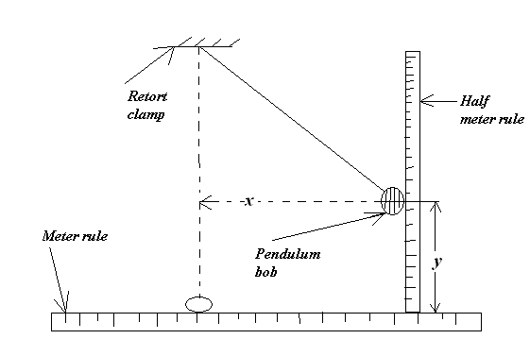

1. Suspend the given pendulum from a retort stand.
2. Displace the pendulum bob through a distance x= 15.0 cm as shown in the figure above.
3. Measure and record the vertical displacement y of the bob.
4. Repeat procedures (b) and (c) for x =20.0, 25.0, 30.0, and 40.0 cm.
5. Record your results in a suitable table including values of x2.
6. Plot a graph of x2 against y.
7. Find the slope, s, of the graph.
8. Calculate the length of the pendulum *lo ,*from

***Lo =***

***No.1.***

* columnlar table of values x, y, x2
* units (cm) (cm) (cm2)
* values y and x2;

|  |  |  |
| --- | --- | --- |
| x | y | X2 |
| 15.0 | -(1.5-2.0) | 225 |
| 00.0 | -(2.5-3.0) | 400 |
| 25.0 | -(4.5-5.0) | 625 |
| 30.0 | -(6.5-7.0) | 900 |
| 40.0 | -(13.0-14.0) | 1600 |

Graph;

* Title of graph (x2Vs y)
* Axes labeled with units
* Marked axes with uniform scale
* Plotting of values (correctly plotted)
* Indication of slope triangle.
* Calculation of the slopes.
* Value ofo; from expression.

**Method II**

1. Displace the pendulum bob through a small angle and release it.
2. Measure the time for the pendulum to make 20 oscillations.
3. Find the period ,T, of the pendulum
4. Calculate the length of the pendulum *lo*from

***Lo = 24.5*T2**

* Time for 20 oscillations-33.0s
* calculation of T- 1.65s
* value of T2-2.7252
* value of o =24.5-2=66.6 cm

1. **In this experiment, you will determine the refractive index, n, of the material of the glass block provided.**

**Y**

**A**

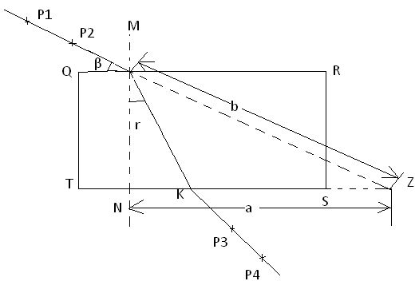

1. Fix the plane piece of paper on the soft board.
2. Place the glass block on the paper and trace its outline QRST as shown in the figure above.
3. Remove the block
4. Draw a normal MN at Y, 2.0 cm from Q.
5. Draw AY at an angle = 25o to QY
6. Fix pins P1 and P2 along AY
7. Replace the block to its outline.
8. While viewing from side ST, fix pins P3 and P4 so that they appear to be in line with pins P1 and P2.
9. Remove the block and join P3 and P4 to meet ST at K
10. Join K to Y
11. Produce AY and TS to meet at Z
12. Measure and record lengths ,a, b and angle r
13. Repeat procedures (*e*) to (*l*) for values of β = 35o, 45o, 55o, 65o, and 75o.
14. Record your results in a suitable table including values of sin r, and $\frac{a}{b}$.
15. Plot a graph of $\frac{a}{b}$ against sin r .
16. Calculate the slope, n, of the graph.

* Design of a table
* Units corresponding in table.

(0), cm, cm, cm (o),-,-,-

|  |  |  |  |  |  |
| --- | --- | --- | --- | --- | --- |
| B(0) | a(cm) | b(cm) | r(0) | Sin r |  |
| 25 | 13.9 | 15.4 | 36 | 0.588 | 0.903 |
| 35 | 8.9 | 14.0 | 34 | 0.559 | 0.636 |
| 45 | 6.3 | 8.9 | 28 | 0.469 | 0.708 |
| 55 | 4.4 | 7.7 | 22 | 0.375 | 0.571 |
| 65 | 2.9 | 6.9 | 14 | 0.242 | 0.420 |
| 75 | 1.8 | 6.3 | 10 | 0.174 | 0.277 |

Values of a

Values of b

Values of c

Calculated values of $a/b$

Values of sin $e$

Title of the graph $a/b$ against sin r

Drawing and labeling the axes

Suitable and convenient scale

Correctly piloted 6 points

Best line

Method of finding the slope.

Calculation of the slope

$\frac{1.08-0.1}{0.7-0.06}$ = $\frac{0.98}{0.64}$ =1.53

Sketch; 1 fixing pins

Outline

Measurement of angles;

1. **In this experiment you will determine the resistance per meter of the wire provided.**
2. Connect the dry cells provided in series with a 5 ohm resistor, ammeter**A** and voltmeter **V** as shown in the figure below.
3. Connect the end Q of the wire mounted on a meter rule to the circuit a shown.

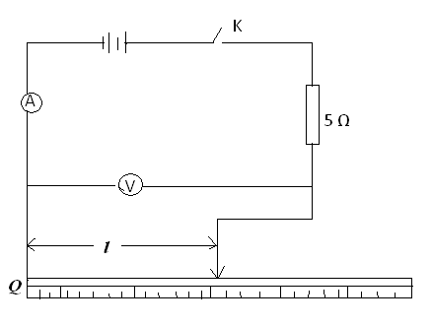

1. Connect a length $ι$ = 0.20 m of the wire across the voltmeter.
2. Close switch K
3. Record the voltmeter reading V and the ammeter reading **I**
4. Open switch K
5. Repeat procedures (c) to (f) for values of $ι$ = 0.30, 0.40, 0.50, 0.60, and 0.70m.
6. Record your results in a suitable table including values of **I $ι$**
7. Plot a graph of **V** (along the vertical axis) against **I $ι$**(along the horizontal axis).
8. Find the slope**s**, of the graph.

columnlas table of $ι$, v, I, I $ι$.

Units (m) (V) (A) (Am)

Values of V

Values of I

Calculated value of I $ι.$-

|  |  |  |  |
| --- | --- | --- | --- |
| $ι$ (m) | V(V) | I(A) | I $l$ |
| 0.20 | 0.50 | 0.38 | 0.08 |
| 0.30 | 0.70 | 0.32 | 0.10 |
| 0.40 | 0.80 | 0.30 | 0.12 |
| 0.50 | 0.90 | 0.28 | 0.14 |
| 0.60 | 1.00 | 0.26 | 0.16 |
| 0.70 | 1.20 | 0.26 | 0.18 |

* Title of the graph V against I $l$
* Axes labeled with units
* Marked axes with uniform scale
* Correctly plotted values
* Best line

Indication of the slope

Calculation of the slope, S,

$\frac{0.85-0.15}{0.21-007}$ (With units) Ω m-1

=5Ω m-1

**END**